**BACKGROUND:**

The novel coronavirus originating from Wuhan City, China has now spread to several dozen countries, including localities in North America, Europe, Asia, and the Australasian region.

This virus (COVID-19) has caused concern among global health authorities since it is believed to have recently jumped from animals to humans and there are now confirmed cases of human-to-human transmission - making it potentially very dangerous in human populations since there is currently no vaccine and little or no immunity.

Coronavirus is a species of virus that has several potentially deadly strains, including the past spread of SARS-CoV (Severe Acute Respiratory Syndrome) and MERS-CoV (Middle East Respiratory Syndrome). Known symptoms of the illness include **fever, difficulty breathing, cough,** and other milder **respiratory** **symptoms** such as **sneezing**.

**PURPOSE:** When widespread disease outbreaks such as Pandemic Flu, Measles, and Novel (New) Viruses threaten Kansas certain temporary measures will be implemented to effectively screen 9-1-1 calls for the protection of emergency response personnel and the public. These efforts will be closely coordinated with all of our public health partners and modified regularly based on the latest scientific research and expert advice concerning the threat.

Maintaining patient confidentiality, as always, is important and radio transmissions to alert first responders of any infectious disease should be restricted to simply using the term Signal 12. Responders are expected to approach those scenes having properly donned the appropriate personal protective equipment (PPE) in advance and take appropriate precautions.

**POLICY: Effective March 1st until rescinded, the Emerging Infectious Disease Surveillance (EIDS) Tool in Paramount will be utilized based on key question answers and the following procedures will be followed.**

**PROCEDURE:**

This SOP applies to all emergency disciplines responding to calls that meet the screening criteria as set forth by the International Academies of Emergency Dispatch’s surveillance tool designed specifically for the existing threat. The tool is located at the top of the Paramount software:

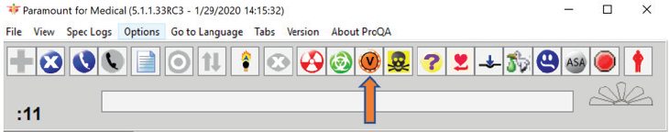

1. Call handling will be conducted in accordance with SOP # IR 1: Incoming Reports Procedure.
2. When symptoms include any of the following the EIDS tool  will be opened and completed **following delivery of** **PDIs**.
   1. Fever
   2. Cough
   3. Shortness of breath
3. Many of these calls will be reports of flu like symptoms which are handled on protocol 26. It is critical that the highest priority that applies be selected, for example, a Delta level if the patient is not alert on protocol 26.When **no priority symptoms** are present and the caller reports a chief complaint equivalent of they suspect the patient has COVID-19, the call taker should select the 26A12 code as shown below. The code 26A12 has changed from possible meningitis to Coronavirus Illness.

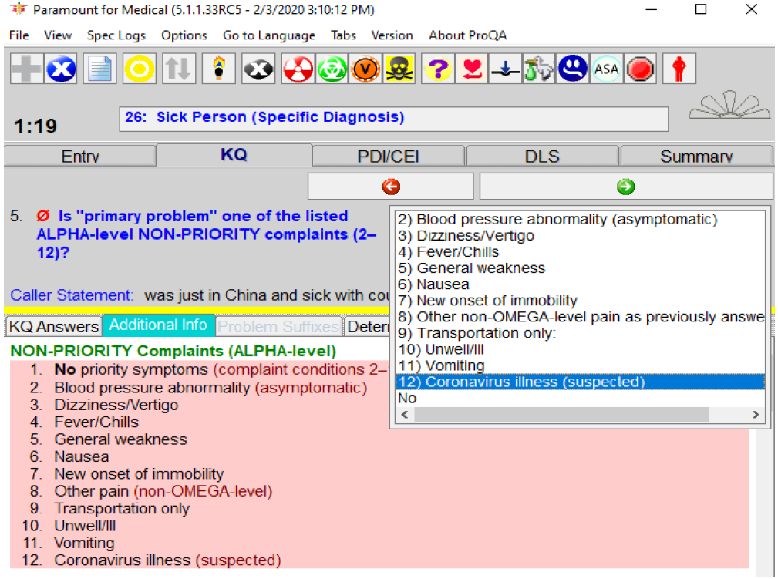

1. **The EIDS Tool** currently has the following question set. As information changes the IAED will update these questions appropriately. Additionally, the Medical Director may insert questions or instructions at any time.

The Medical Director Questions 1 and 2 REPLACE the first three travel history questions.

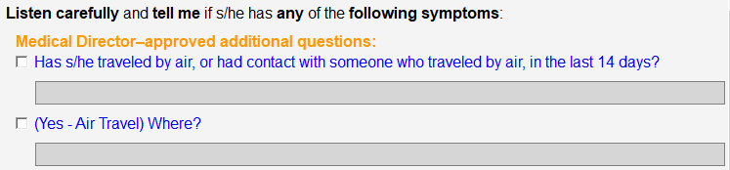

The next question should be: *Has s/he had* contact with someone with flu-like illness (if so when)?

**Current Definitions:**

* 1. **Hot Area** = Traveled by Air.
  2. **Keep Isolated** = Infection Prevention Instructions are NOT in use at this time. The (Keep Isolated) pre-instruction qualifier does not apply at this time and instructions with that PIQ are not to be read.

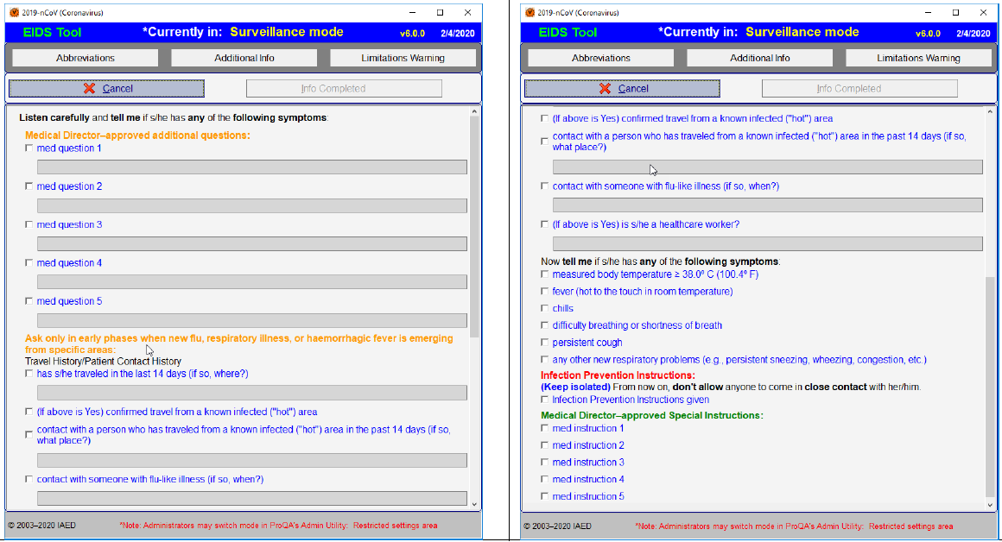

1. The call taker should select all of the relevant answers which will then become part of the EMD narrative in CAD. Once these questions are answered and appear in CAD the **CALL TAKER** must dispatch the unit “EIDS” to the call in order to deliver the answers to the EIDS questions via CAD page. The DISPATCHER should simply advise responding crews that emergency medical information is being sent via CAD Page when they are aware that 2 or more of the questions have been answered “yes”.

**REPORTING:** When the EIDS unit is assigned to the call responding EMS units automatically receive the updated information via Active 911. In addition an email is generated to the group [PANDEMIC@anycounty.com](mailto:PANDEMIC@anycounty.com) to notify all of our public health partners.

KDHE has updated their criteria, so Dr. Dodson has asked us to add another question to the tool:



An official policy update will be coming shortly.

Also, we’ve now had a chance to use this tool live, I wanted to pass along some reminders.

1.     Since we’re asking if the patient has flown or had contact with anyone who traveled by air, we don’t have to ask if they’ve traveled. You’ll find this in the policy in section IV. After asking the Medical Director questions, skip down do the “Has s/he had contact with someone with flu-like illness?”

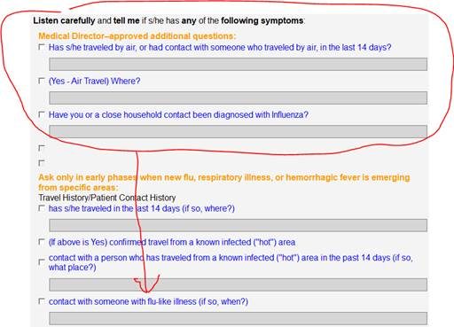

2.     The “Healthcare worker” question is only asked IF the caller reports having contact with someone with flu-like symptoms. (The idea is not to ask if they are a healthcare worker. The idea is to see if they may have gotten sick from contact with a healthcare worker.)

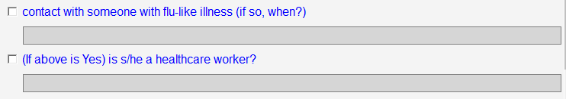

3.     We are NOT giving the “Keep Isolated” instruction at this time.

4.     Someone has to let the crew know to check CAD page for EMS information, after EIDS has been dispatched to the call and ideally before they arrive on scene.

Additional information links:

<https://www.emergencydispatch.org/coronavirus-2019-nCoV>

<https://www.arcgis.com/apps/opsdashboard/index.html#/bda7594740fd40299423467b48e9ecf6>

<https://www.cdc.gov/>